Issue description – Azure web app
Overview: The Azure Web app “cveu-t-mcc-handover-001” experiences intermittent outbound network connectivity issues after slot swaps. Symptoms of this error are:
- HTTP 500 errors when trying to navigate to the web app in a browser
- The app uses Hangfire to run scheduled jobs and these are all failing with TCP errors.
- Simply restarting the app from the Azure portal resolves the issue

Application logs:
Analyzing the application logs suggests that the issue is directly related to the slot swap operation.
The application is deployed via an Azure Devops pipeline that performs the following operations:
- Deploy an ARM template that deploy the application and a staging slot.
- Deploy the latest build artifact to the staging slot.
- Apply web app configuration to the staging slot (the settings are not sticky).
- Swap staging slot with production.

The following picture shows the application starting up and functioning properly during the slot swap:
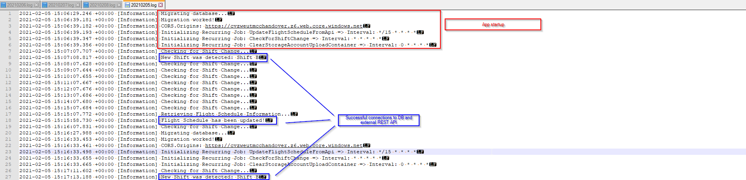

The slot swap started at 2021-02-05T15:04:49 and completed at 2021-02-05T15:17:32:
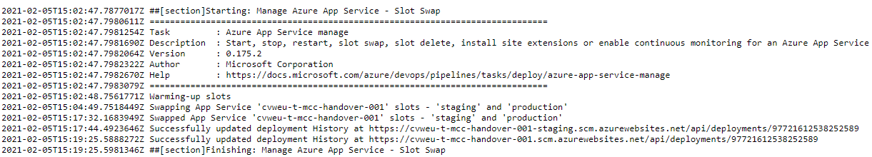

Immediately after the slot swap, the scheduled jobs are failing with network errors:
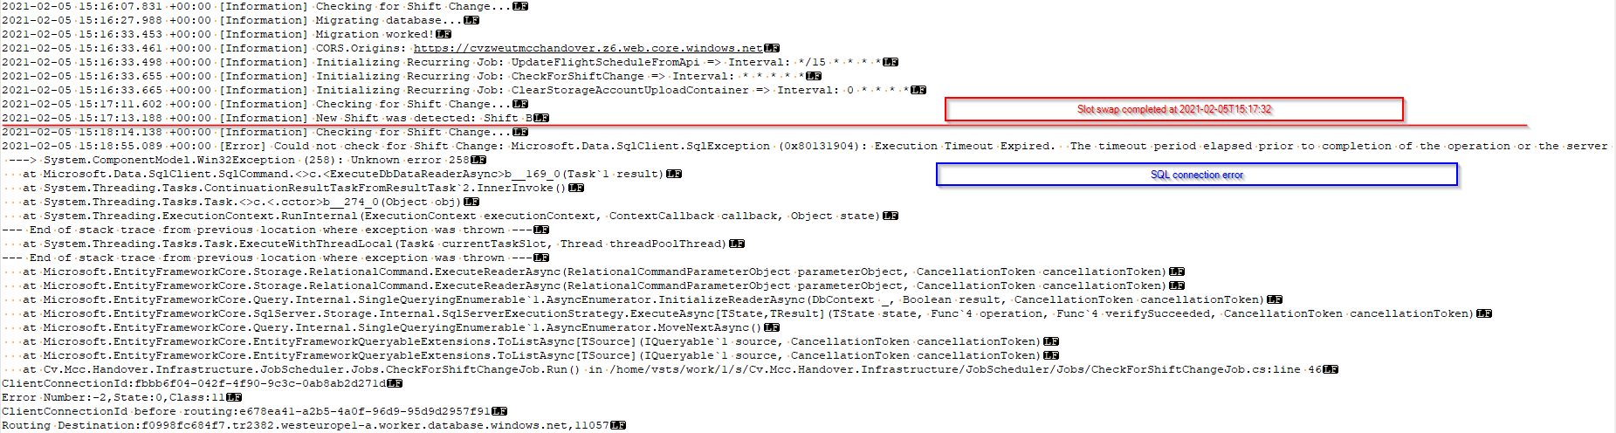
The errors are not only generated on by the SQL client. Here are a few samples:
2021-02-05 15:18:55.089 +00:00 [Error] Could not check for Shift Change: Microsoft.Data.SqlClient.SqlException (0x80131904): Execution Timeout Expired. The timeout period elapsed prior to completion of the operation or the server is not responding.
---> System.ComponentModel.Win32Exception (258): Unknown error 258
at Microsoft.Data.SqlClient.SqlCommand.<>c.<ExecuteDbDataReaderAsync>b__169_0(Task`1 result)
at System.Threading.Tasks.ContinuationResultTaskFromResultTask`2.InnerInvoke()
at System.Threading.Tasks.Task.<>c.<.cctor>b__274_0(Object obj)
at System.Threading.ExecutionContext.RunInternal(ExecutionContext executionContext, ContextCallback callback, Object state)
--- End of stack trace from previous location where exception was thrown ---
at System.Threading.Tasks.Task.ExecuteWithThreadLocal(Task& currentTaskSlot, Thread threadPoolThread)
--- End of stack trace from previous location where exception was thrown ---
at Microsoft.EntityFrameworkCore.Storage.RelationalCommand.ExecuteReaderAsync(RelationalCommandParameterObject parameterObject, CancellationToken cancellationToken)
at Microsoft.EntityFrameworkCore.Storage.RelationalCommand.ExecuteReaderAsync(RelationalCommandParameterObject parameterObject, CancellationToken cancellationToken)
at Microsoft.EntityFrameworkCore.Query.Internal.SingleQueryingEnumerable`1.AsyncEnumerator.InitializeReaderAsync(DbContext _, Boolean result, CancellationToken cancellationToken)
at Microsoft.EntityFrameworkCore.SqlServer.Storage.Internal.SqlServerExecutionStrategy.ExecuteAsync[TState,TResult](TState state, Func`4 operation, Func`4 verifySucceeded, CancellationToken cancellationToken)
at Microsoft.EntityFrameworkCore.Query.Internal.SingleQueryingEnumerable`1.AsyncEnumerator.MoveNextAsync()
at Microsoft.EntityFrameworkCore.EntityFrameworkQueryableExtensions.ToListAsync[TSource](IQueryable`1 source, CancellationToken cancellationToken)
at Microsoft.EntityFrameworkCore.EntityFrameworkQueryableExtensions.ToListAsync[TSource](IQueryable`1 source, CancellationToken cancellationToken)
at Cv.Mcc.Handover.Infrastructure.JobScheduler.Jobs.CheckForShiftChangeJob.Run() in /home/vsts/work/1/s/Cv.Mcc.Handover.Infrastructure/JobScheduler/Jobs/CheckForShiftChangeJob.cs:line 46
ClientConnectionId:fbbb6f04-042f-4f90-9c3c-0ab8ab2d271d
Error Number:-2,State:0,Class:11
ClientConnectionId before routing:e678ea41-a2b5-4a0f-96d9-95d9d2957f91
Routing Destination:f0998fc684f7.tr2382.westeurope1-a.worker.database.windows.net,11057

2021-02-05 15:30:13.672 +00:00 [Information] Retrieving Flight Schedule Information...
2021-02-05 15:30:33.849 +00:00 [Error] Something went wrong while requesting new schedule from FS Api: System.Net.Http.HttpRequestException: Resource temporarily unavailable
---> System.Net.Sockets.SocketException (11): Resource temporarily unavailable
at System.Net.Http.ConnectHelper.ConnectAsync(String host, Int32 port, CancellationToken cancellationToken)
--- End of inner exception stack trace ---
at System.Net.Http.ConnectHelper.ConnectAsync(String host, Int32 port, CancellationToken cancellationToken)
at System.Net.Http.HttpConnectionPool.ConnectAsync(HttpRequestMessage request, Boolean allowHttp2, CancellationToken cancellationToken)
at System.Net.Http.HttpConnectionPool.CreateHttp11ConnectionAsync(HttpRequestMessage request, CancellationToken cancellationToken)
at System.Net.Http.HttpConnectionPool.GetHttpConnectionAsync(HttpRequestMessage request, CancellationToken cancellationToken)
at System.Net.Http.HttpConnectionPool.SendWithRetryAsync(HttpRequestMessage request, Boolean doRequestAuth, CancellationToken cancellationToken)
at System.Net.Http.RedirectHandler.SendAsync(HttpRequestMessage request, CancellationToken cancellationToken)
at System.Net.Http.HttpClient.FinishSendAsyncBuffered(Task`1 sendTask, HttpRequestMessage request, CancellationTokenSource cts, Boolean disposeCts)
at Cv.Mcc.Handover.Infrastructure.Services.FlightSchedule.FlightScheduleService.GetFlightSchedule(Int32 minusDays, Int32 plusDays) in /home/vsts/work/1/s/Cv.Mcc.Handover.Infrastructure/Services/FlightSchedule/FlightScheduleService.cs:line 59
at Cv.Mcc.Handover.Infrastructure.JobScheduler.Jobs.FlightScheduleApiUpdateJob.Run() in /home/vsts/work/1/s/Cv.Mcc.Handover.Infrastructure/JobScheduler/Jobs/FlightScheduleApiUpdateJob.cs:line 46

The errors keep occurring until the application is restarted from the Azure portal:
